SYD366 Sales and Scheduling Test Summer 2021

**SYD 366 - Sales and Scheduling Test (30% of final grade)**

**Part 1: Sales**

**Question 1** (worth 15 marks)

Complete a **class diagram** to support what your team has learned about invoicing for *Guelph Tutors.* Class diagrams must include any associations, association names, multiplicity, and reference attributes (including any sets).

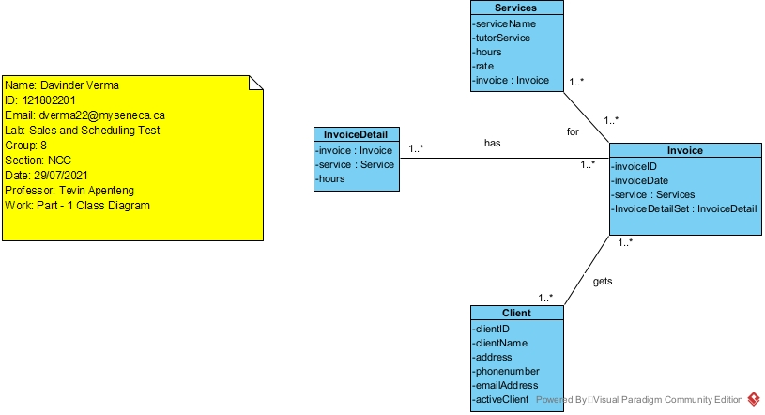

**Question 2** (worth 20 marks)

Complete an **object level sequence** diagram for the above scenario.

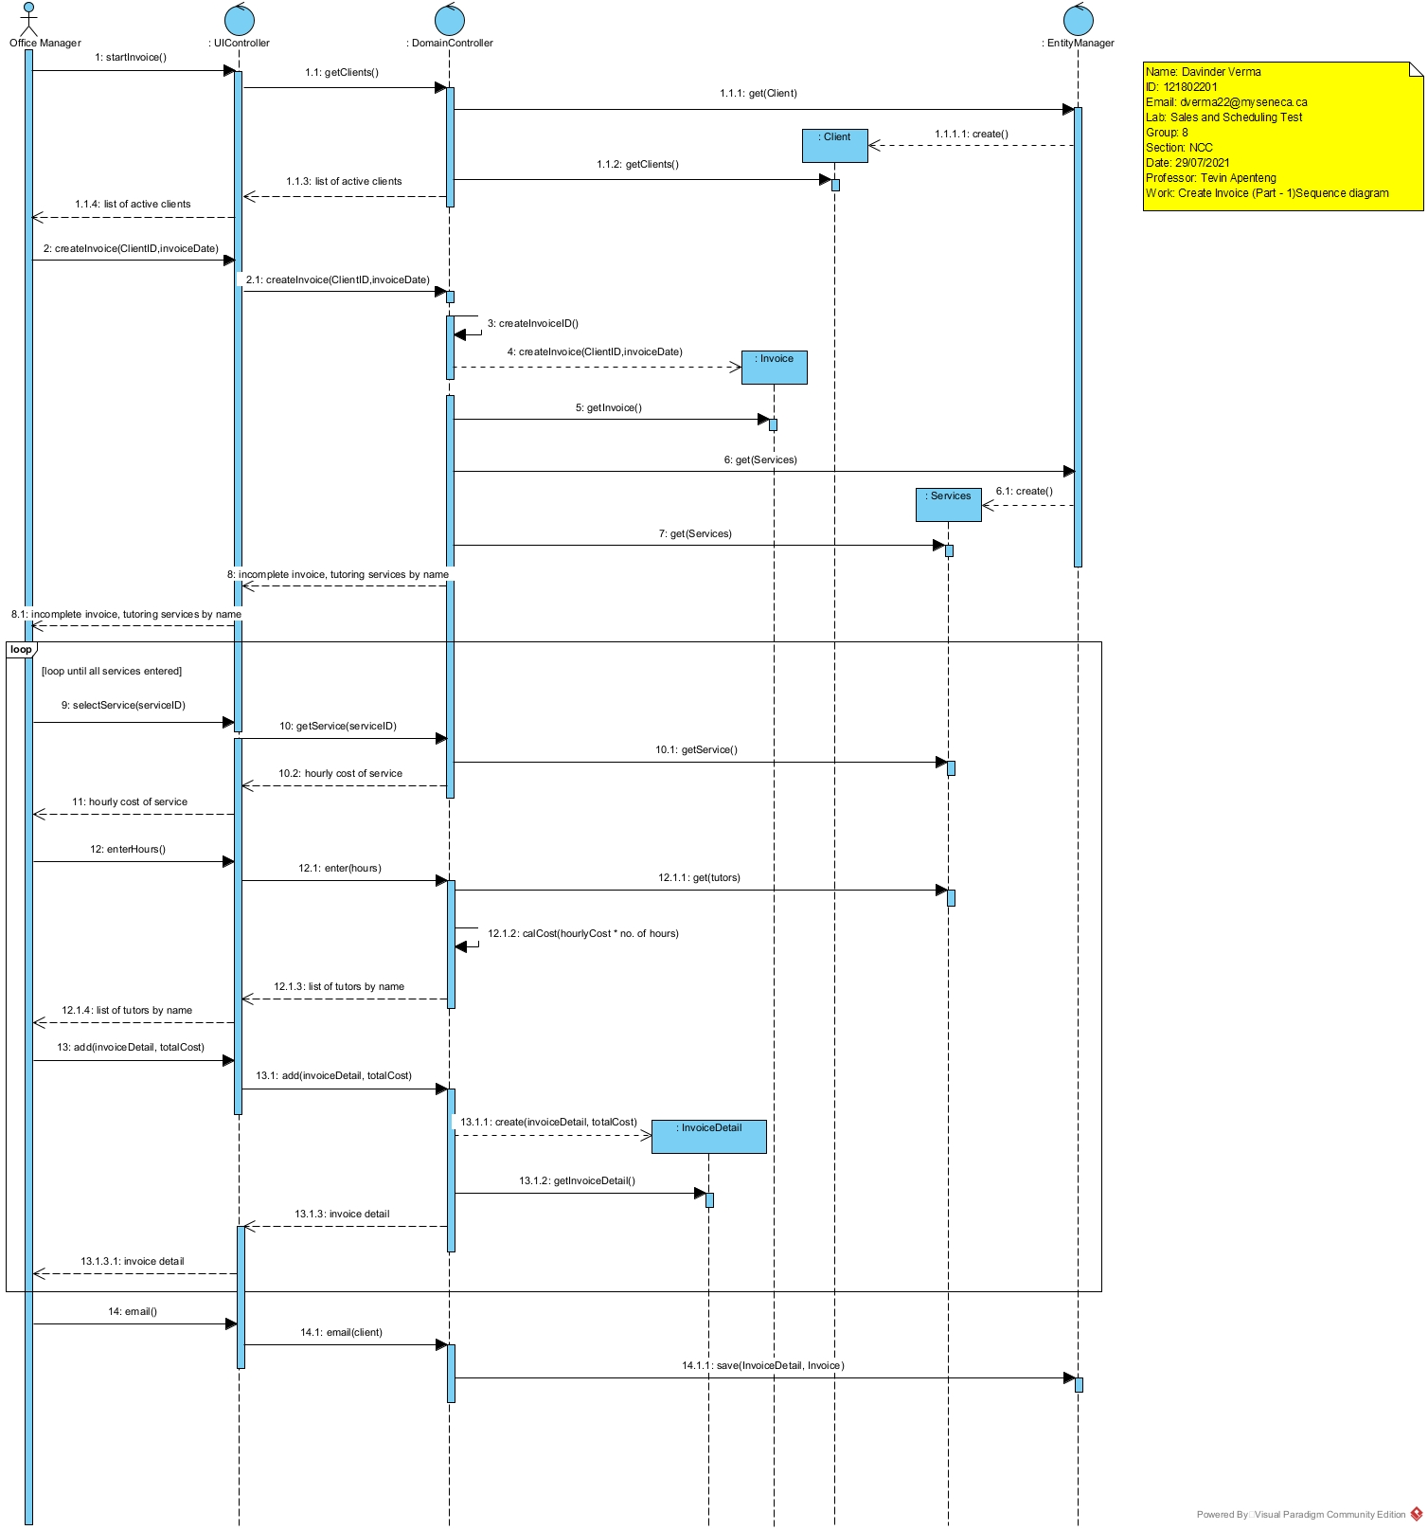

*Answer all the following questions in clear English.*

**Question 3** (worth 2 marks)

The above scenario assumes that the hourly cost for a service is the same for each tutor. What would happen if the hourly cost changed for each tutor providing the tutoring service? How would you change your model?

***Ans****. If every tutor will have different hourly rate, then I will add another attribute in the Service class (hourlyRate). Also, when we ask for hours at that we will also ask for the hourly rate to accommodate the change in the model. Rest of the model will be same as it is.*

**Question 4** (worth 2 marks)

*Guelph Tutors* is thinking of offering a gift certificate for clients to purchase to give to their friends. How would you change your model to support this?

***Ans.*** *For accommodating these changes, I will have to modify my model at 2 places. First, before the invoice is total amount is calculated. I will first ask if the customer has gift card or not. If yes, then I will subtract that amount from the total bill. I will also add giftCard attribute in the Invoice class.*

**Part 2: Scheduling**

**Question 5** (worth 10 marks)

Create a **class diagram** to support the activity and the scenario described above. You may use implied data from the description and Schedule Module lab, as necessary.

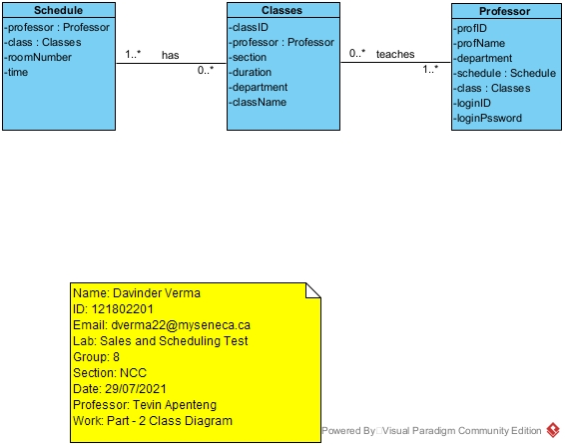

**Question 6** (worth 5 marks)

Complete an **object level sequence** diagram for the above scenario.

